EXP NO : 7 Banker's Algorithm
`C PROGRAM
#include <stdio.h>

int main()
{
int n, m, i, j, k;
int allocation[10][10], max[10][10];
int need[10][10];
int available[10];
int finish[10] = {0};
int safeSeq[10];
int count = 0;

printf("Enter Number of Processes: ");
scanf("%d", &n);

printf("Enter Number of Resources: ");
scanf("%d", &m);

printf("\nEnter Allocation Matrix:\n");
for(i = 0; i < n; i++)
for(j = 0; j < m; j++)
scanf("%d", &allocation[i][j]);
printf("\nEnter Maximum Matrix:\n");
for(i = 0; i < n; i++)
for(j = 0; j < m; j++)
scanf("%d", &max[i][j]);

printf("\nEnter Available Resources:\n");
for(i = 0; i < m; i++)
scanf("%d", &available[i]);

for(i = 0; i < n; i++)
{
for(j = 0; j < m; j++)
{
need[i][j] = max[i][j] - allocation[i][j];
}
}

while(count < n)
{
int found = 0;

for(i = 0; i < n; i++)
{
if(finish[i] == 0)
{
for(j = 0; j < m; j++)
{ if(need[i][j] > available[j])
break;
}

if(j == m)
{
for(k = 0; k < m; k++)
available[k] += allocation[i][k]; safeSeq[count++] = i;
finish[i] = 1;
found = 1;
}
}
}

if(found == 0)
{
printf("\nSystem is NOT in Safe State\n");
return 0;
}
}
printf("\nSystem is in Safe State\n");
printf("Safe Sequence: ");

for(i = 0; i < n; i++)
printf("P%d ", safeSeq[i]);

printf("\n"); return 0;
}
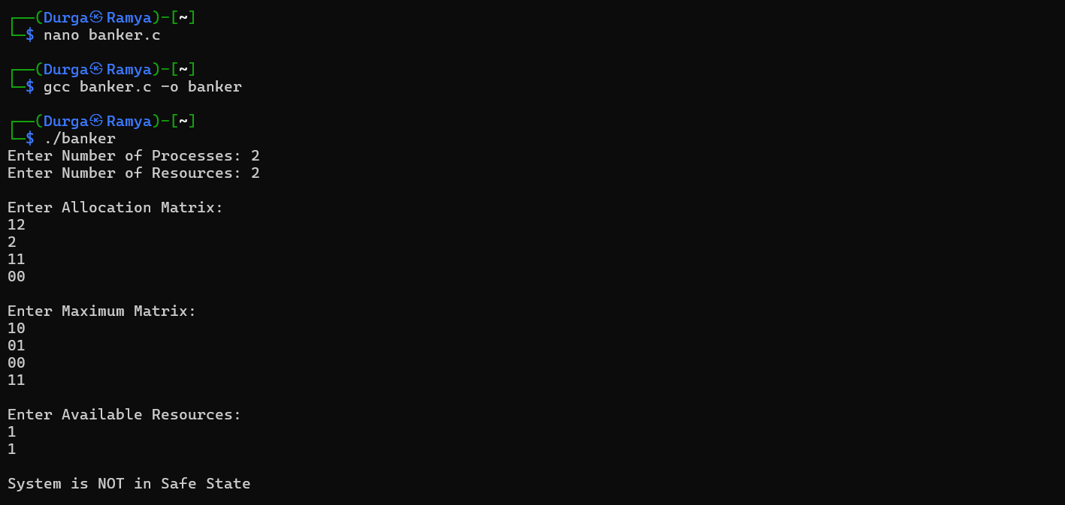

SHELL SCRIPT :
#!/bin/bash
echo "Enter Number of Processes:"
read n
echo "Enter Safe Sequence (space separated):"
read -a seq
echo "Safe Sequence is:"
for ((i=0;i<n;i++))
do
echo -n "P${seq[$i]} "
done
echo
echo "System is in Safe State"
